**2 . Ansible server connection with dockerhost**

**On DOCKERHOST MACHINE DO Below**

Create Linux ec2 instance for dockerhost and login using putty on it.

Switch to user root using sudo su –

Install docker using command yum install docker -y

Check the docker service whether it is running or not

Service docker service

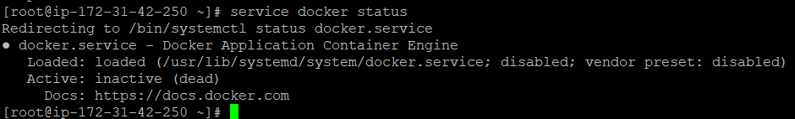

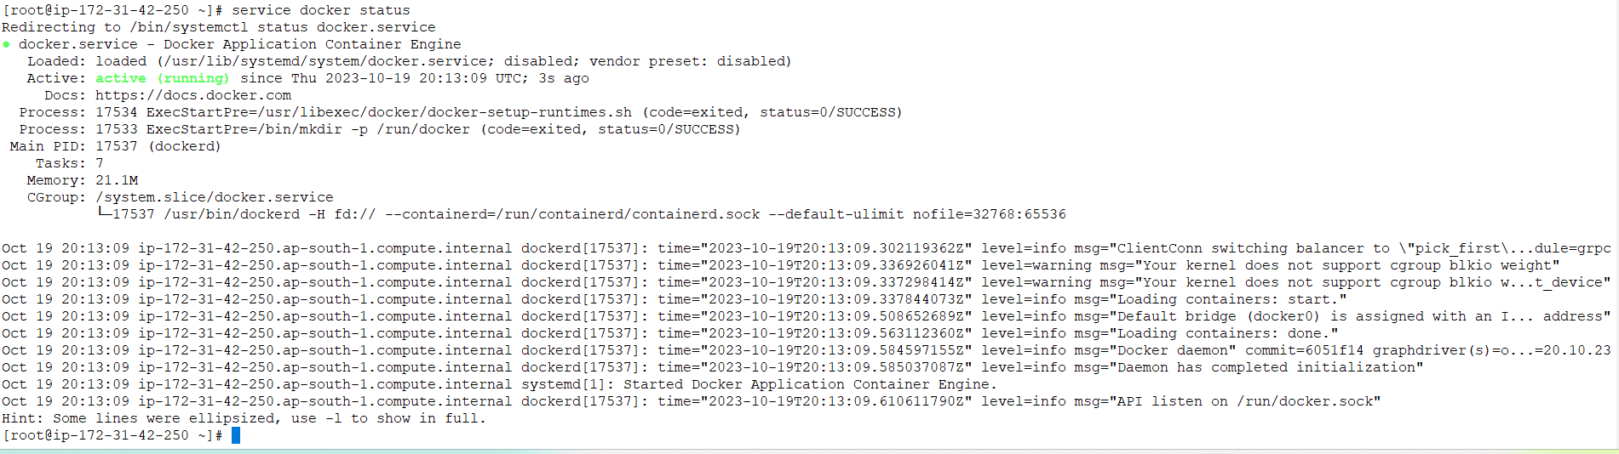

Follow the documents tomcat docker for rest of setup like creating dockeradmin user and docker group

Once you have created dockeradmin user you need to create ansadmin user on docker host

[root@dockerhost ~]# useradd ansadmin

[root@dockerhost ~]# passwd ansadmin

Changing password for user ansadmin.

New password:

BAD PASSWORD: The password is shorter than 8 characters

Retype new password:

passwd: all authentication tokens updated successfully.

[root@dockerhost ~]#

[root@dockerhost ~]# vi /etc/sudoers

ansadmin ALL=(ALL) ALL

[root@dockerhost ~]# vi /etc/ssh/sshd_config

# To disable tunneled clear text passwords, change to no here!

PasswordAuthentication yes

#PermitEmptyPasswords no

#PasswordAuthentication no

**On Ansible MACHINE DO Below**

1. Switch to root user and get the private ip address of ec2 instance
2. vi /etc/ansible/hosts

add ip address in this file

1. Now we want this ansible machine should access to dockerhost machine but using user ansadmin, so switch to ansadmin user
2. [root@anisble-server ~]# su ansadmin

[ansadmin@anisble-server root]$

1. Now in order to talk between ansible m/c and docker m/c, we need to copy ansible id_rsa.pub key into dockerhost machine using command ssh-copy-id <private_ip_address_of_other_machine>

Cd /home/ansadmin/.ssh

Ssh-copy-id 172.31.42.250

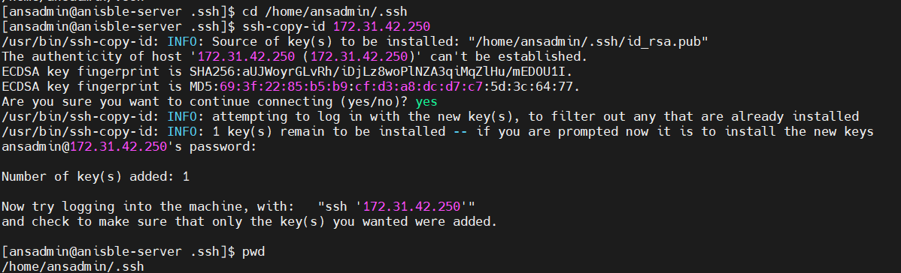



You can go on dockerhost and check that it has created .ssh folder on dockermachine and copied the public key of ansible host into file authorized_keys

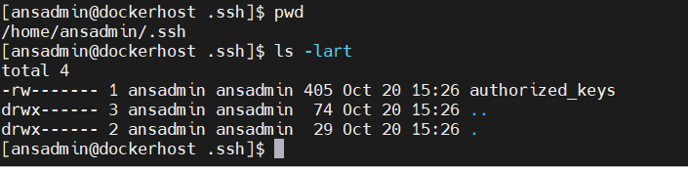



There are two ways you can check whether you are able to connect to docker machine from ansible server

First way:

Using ssh user@ip_address

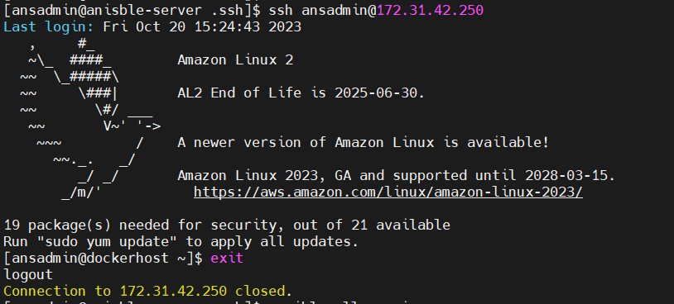

Second way: using ansible command

Ansible all -m ping

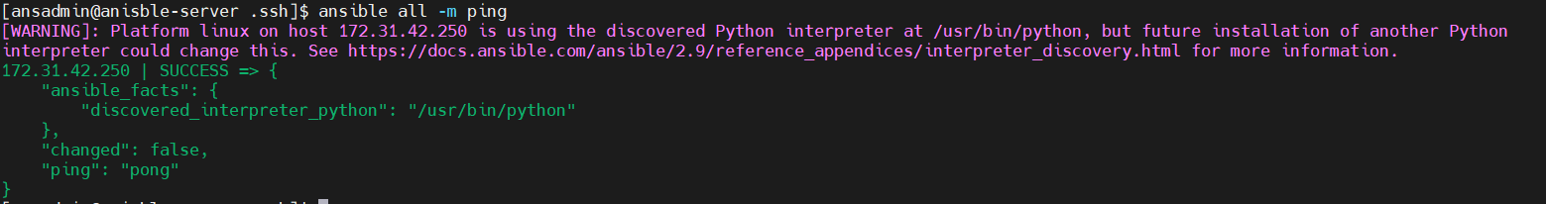

Ansible all -m command -a uptime

**NOW Integrate ansible with jenkins**

Go to Jenkins and go to manage Jenkins

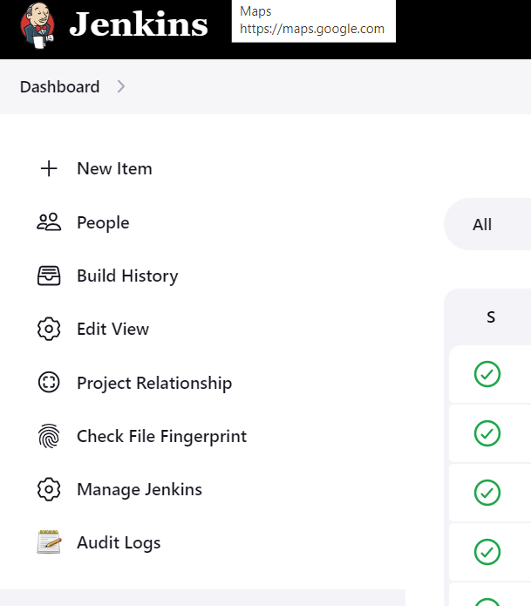

2. Go to system 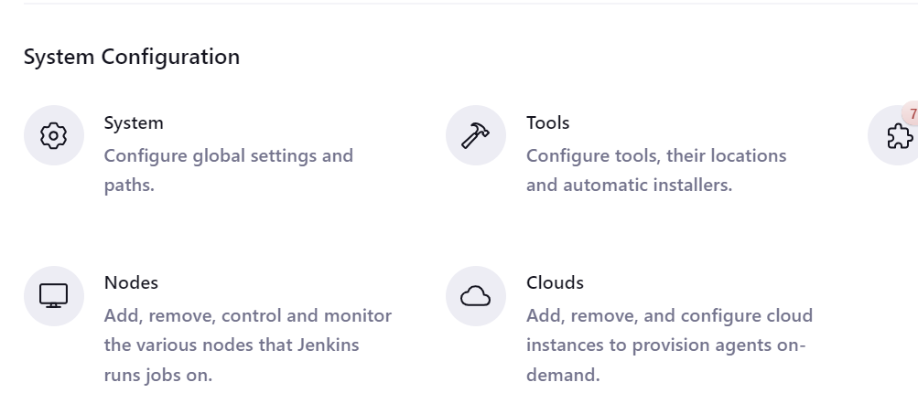



Inside system go to bottom and search for ssh server.

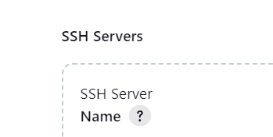

Now click on Add button in bottom to add ansible server detail here. Hostname should be private ip address.

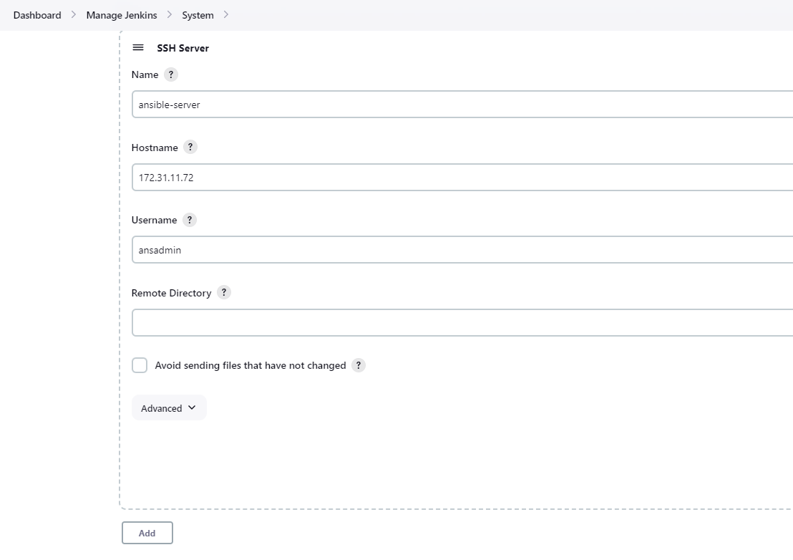

Click on advance and put the password and go in end.

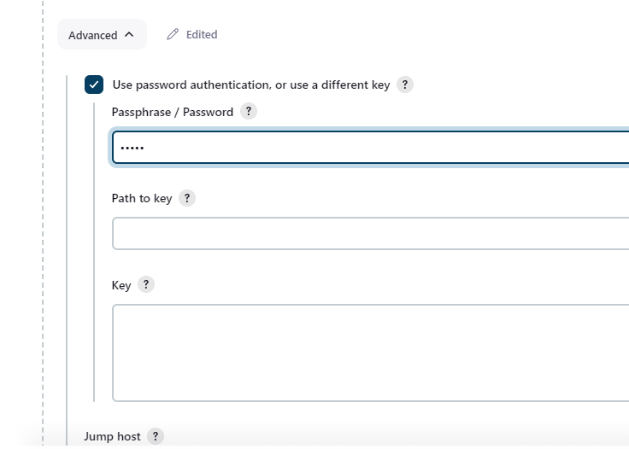

Click button test configuration:

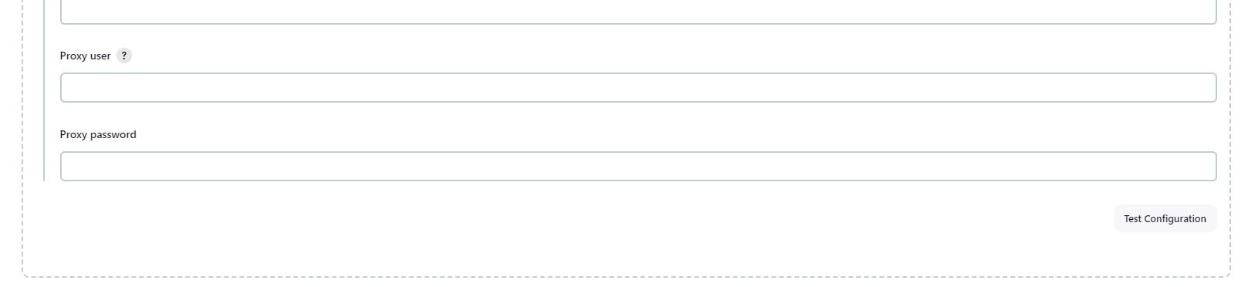

NOW you need to create job in Jenkins to copy the artifact/war on ansible server under /opt/docker,

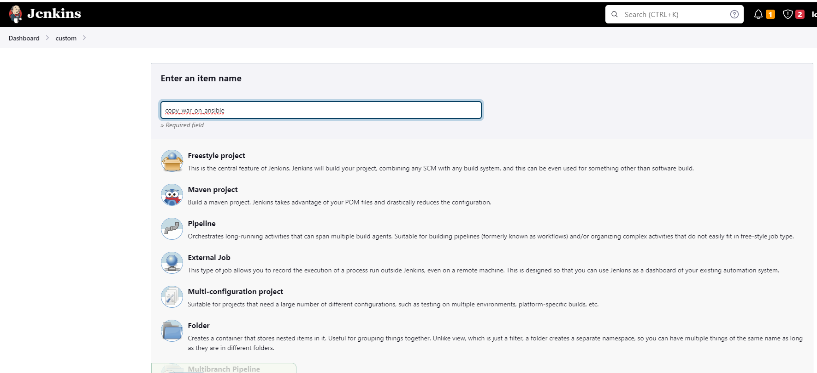

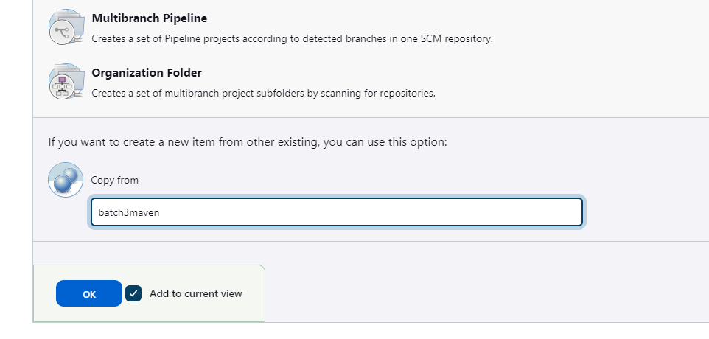

Job looks like below

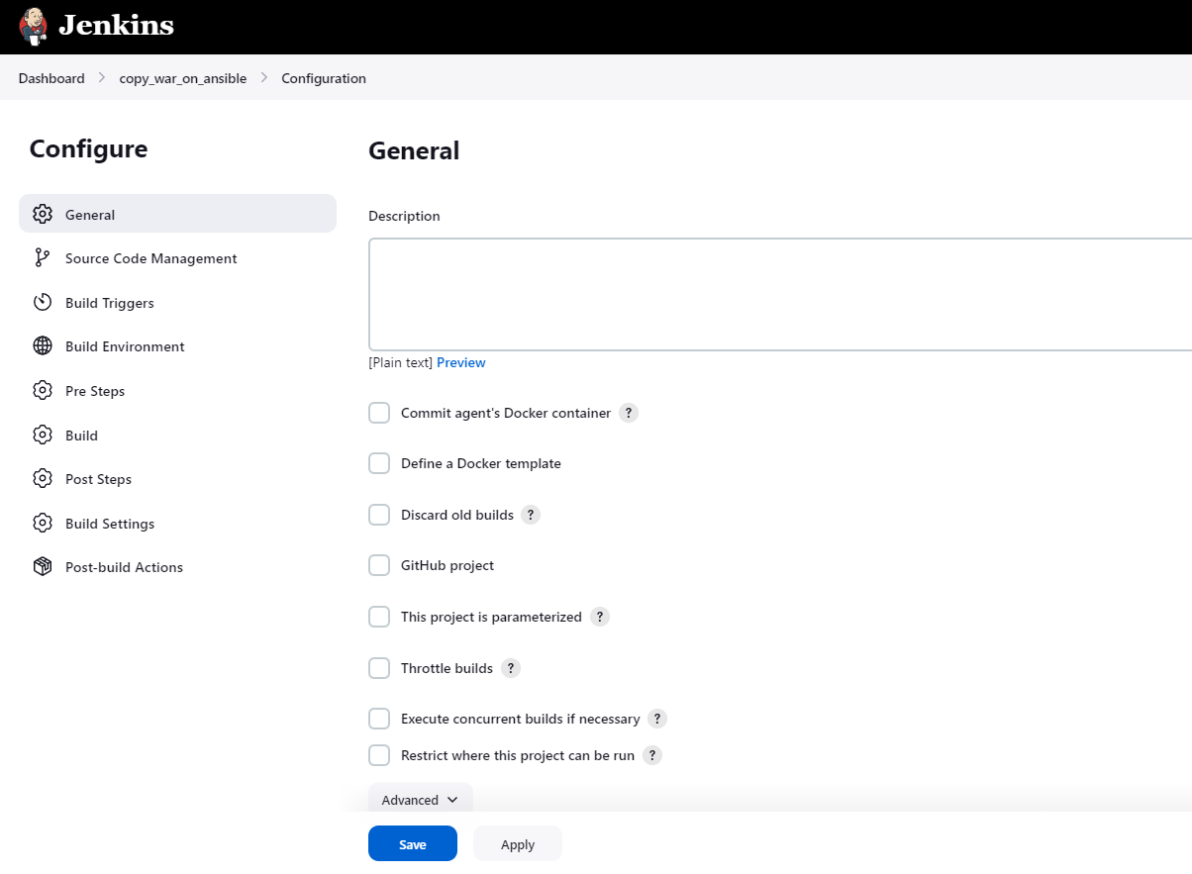

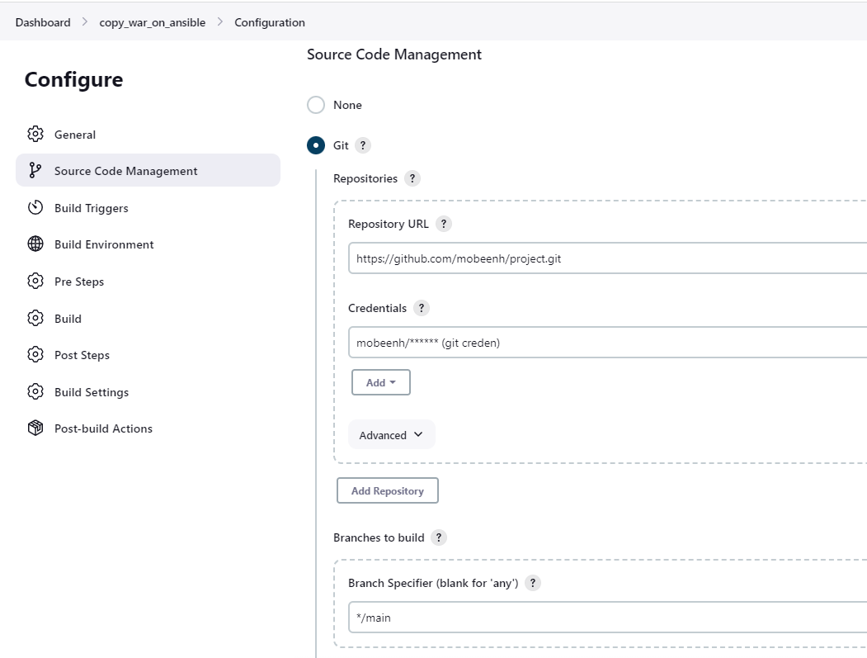

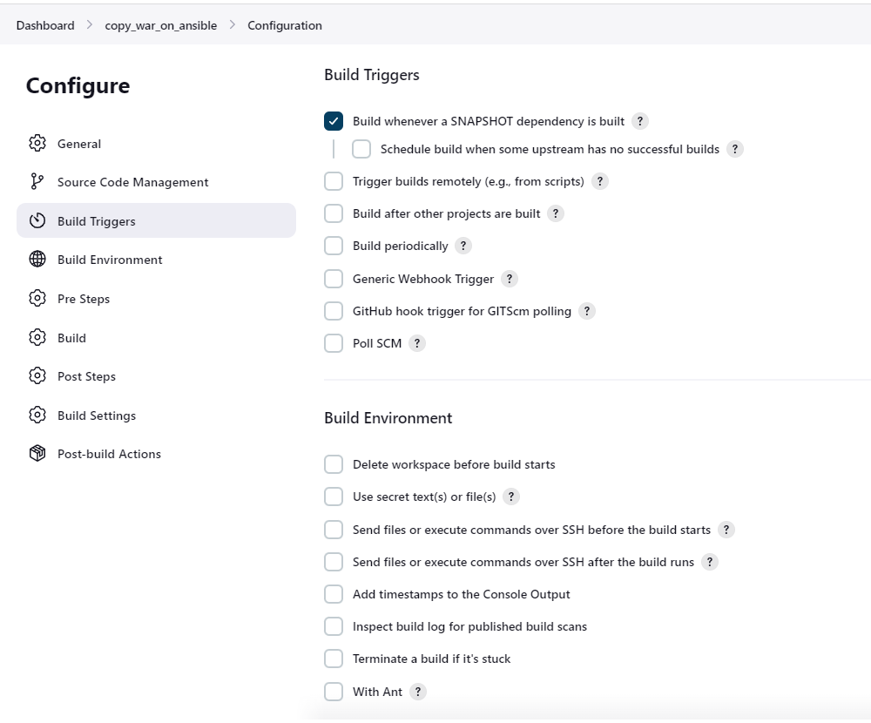

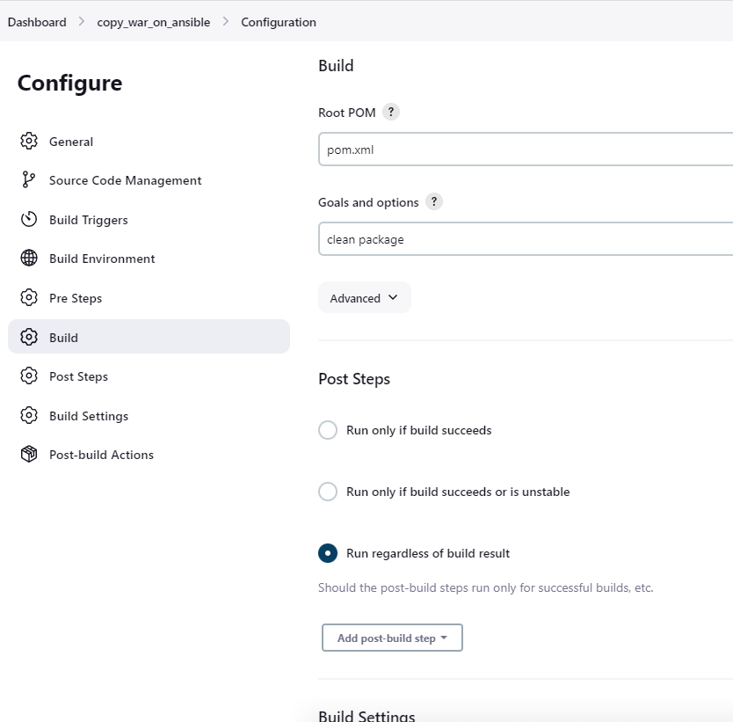

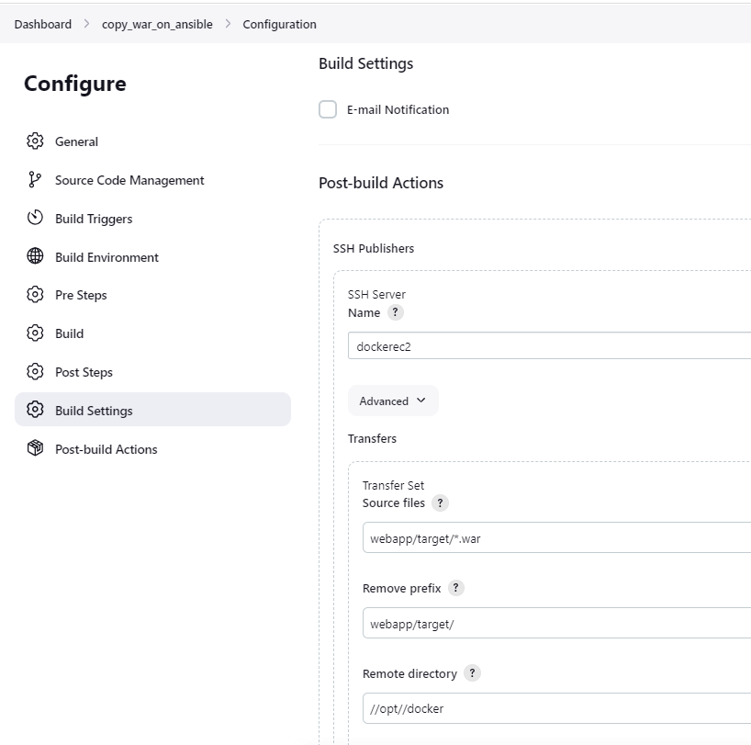

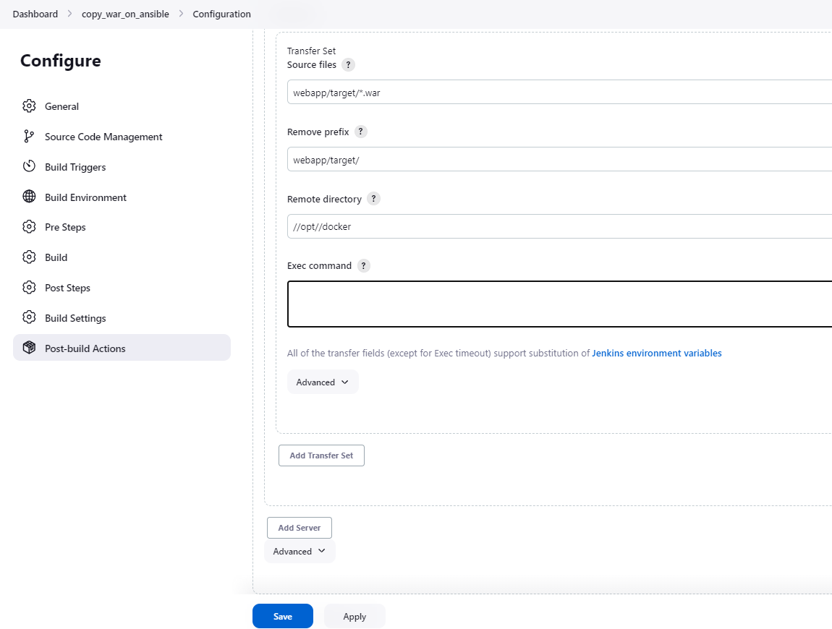

Save and run it. Check the ansible server whether we got the war file in ansible server or not.

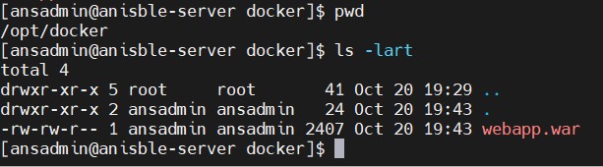

so for that you need to create directory on ansible server. You need to change the ownership of docker folder to ansadmin because ansadmin is the user who will access this folder.

sudo mkdir docker

sudo chown ansadmin:ansadmin docker

